|  |  |  |
| --- | --- | --- |
| **Duy Tan University**  International School  SE-MIS program | **INDIVIDUAL PROJECT**  Course**: FUNDAMETALS OF COMPUTING 1**  Class:  Semester: I Academic year: 2025 - 2026  Duration:  Date: | |
| Student’s name: | | Student’s ID: |
| **Score** | **Examiner’s signature (Giám khảo)** | **Supervisor (Giám thị)** |

**Individual Project:** *Parking Management System*

**Introduction**

The "Parking Management System" is a tool to help parking lots manage vehicles more easily. It allows users to add or remove vehicles, calculate parking fees, and track vehicle information. The system uses a simple Java-based graphical user interface (GUI) to make it easy for users to interact. With features like searching by license plate and organizing vehicles by type or fuel, the system helps manage parking spaces better. It also supports saving and loading data for future use.

|  |  |
| --- | --- |
| **Criteria** | **Points** |
| **Functionality** |  |
| **Class Structure** |  |
| **Code Quality** |  |
| **Documentation** |  |
| **User Interface** |  |
| **Overall Design** |  |

**Link code (Github):** https://github.com/vivian-dangk/ParkingManagemnet

**User interface:**

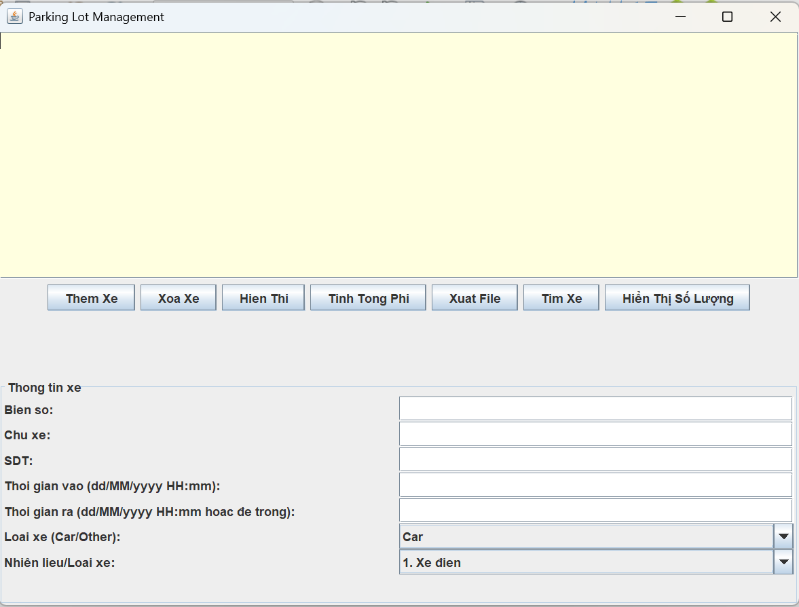

**Add Vehicle:**

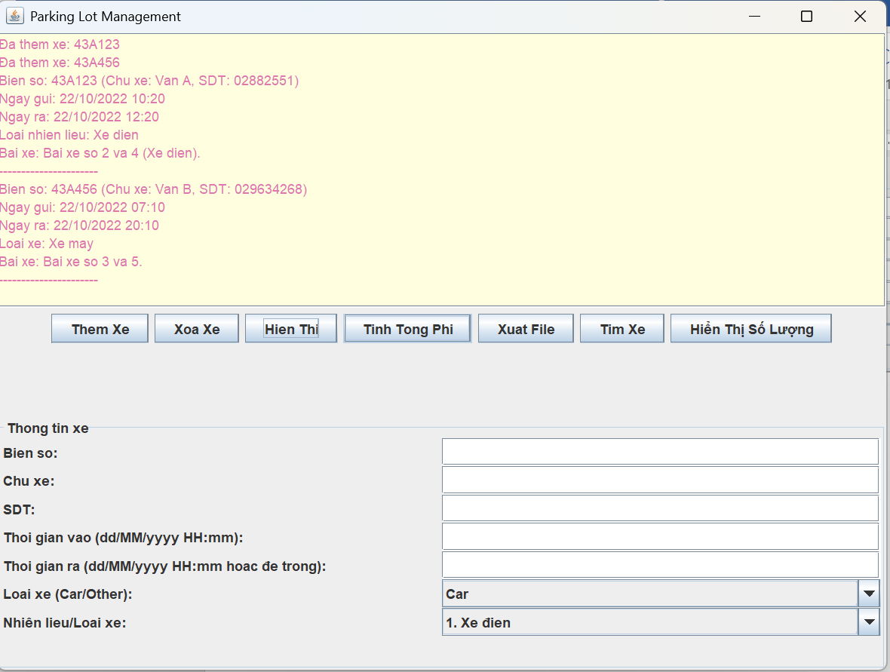

**Display Vehicle**



**Calculate Fee**

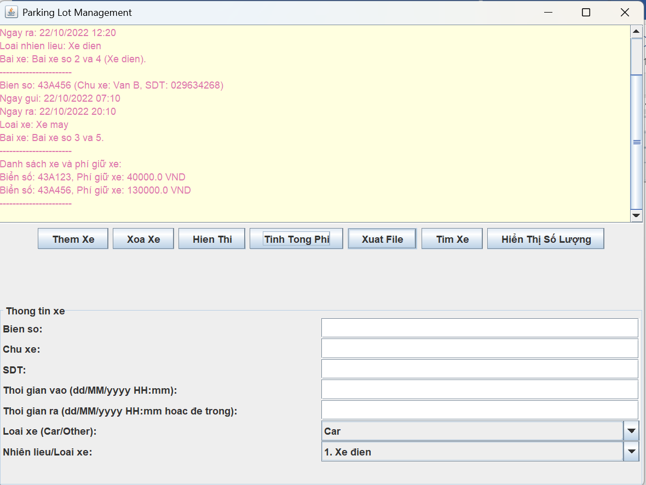

**Find Vehicle**

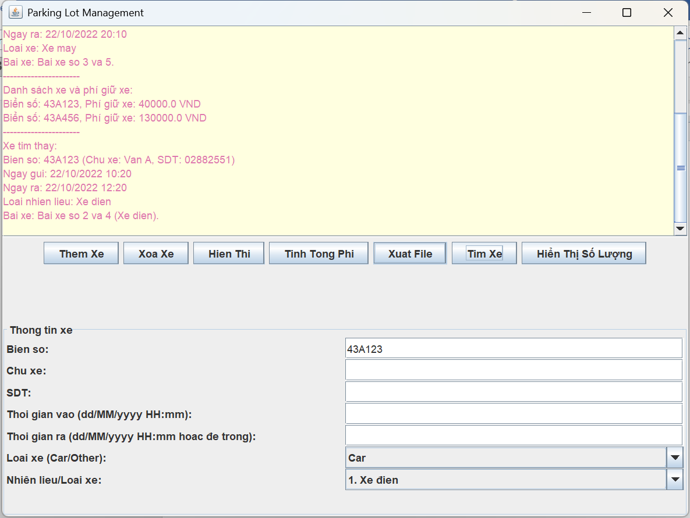

**Remove Vehicle**

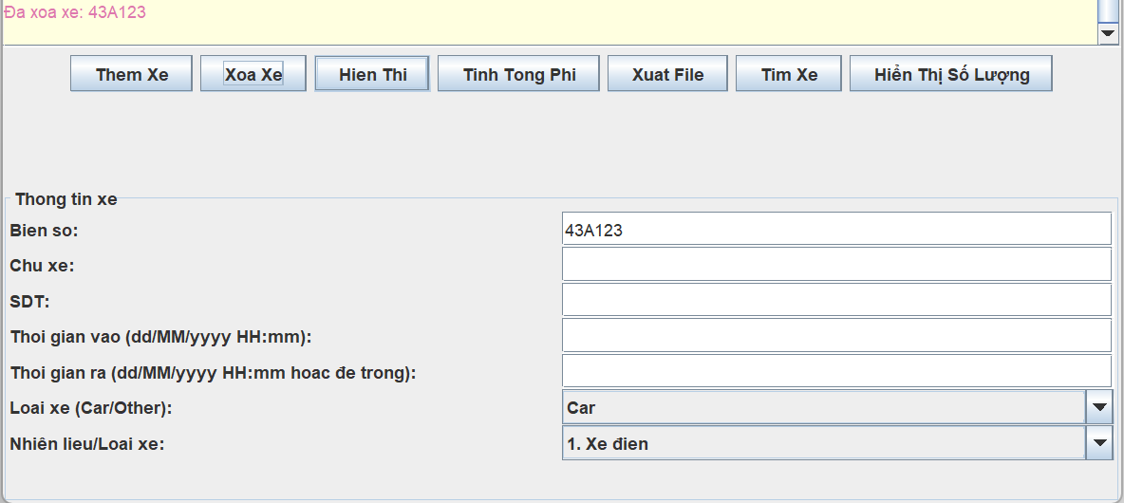

**List Vehicle**

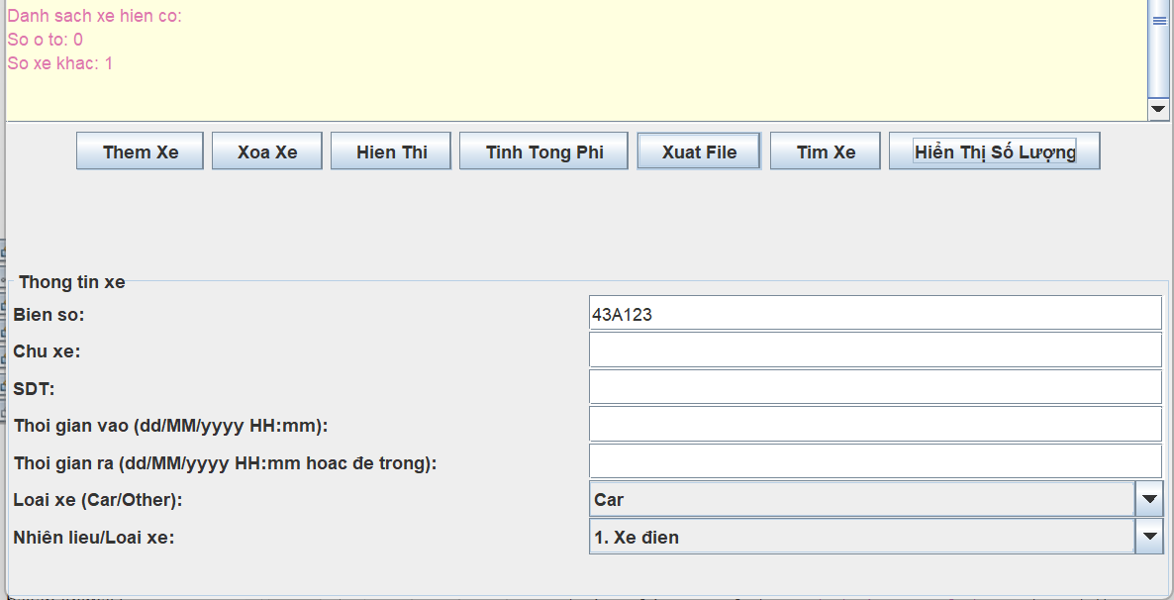

**Export file:**

